1. **Take 4 switches named as: A, B, C, D and connect them in alphabetical order. Perform and show the following configurations in your lab task:**

a. Switch A with VLANs faculty and students having 1 logical port each.

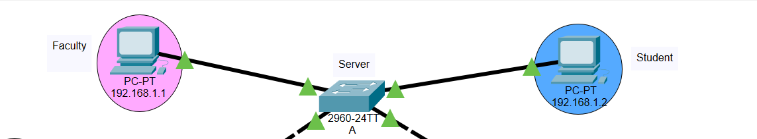

b. Now assign 1 logical port each to VLANs faculty and students in Switch B and D.

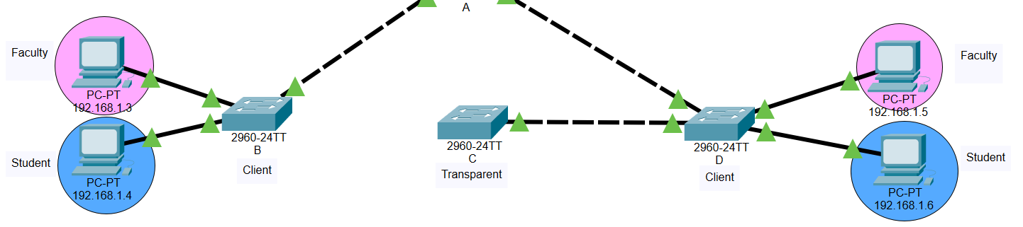

c. Now make switch A in server mode, whereas B and D in client mode and switch C in transparent mode.

**Switch A**

**SWITCH B**

**SWITCH C**

**SWITCH D**

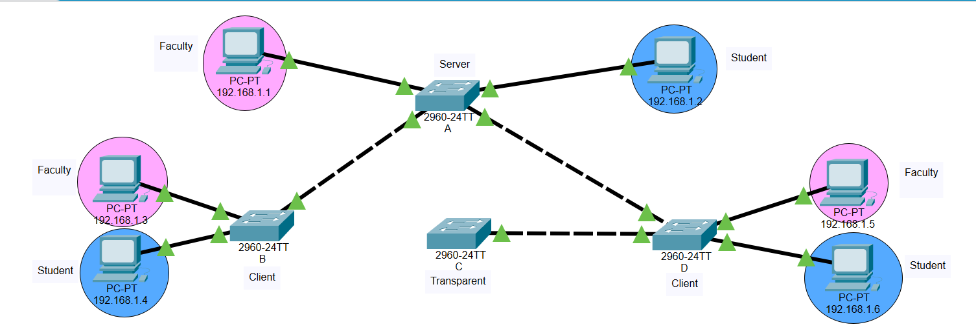 d. Assign IP addresses to PCs connected to Switch A, B and D

e. Now ping within the same VLAN and outside the same VLAN and show your results.

* **Client1 Faculty -> Server (faculty)**

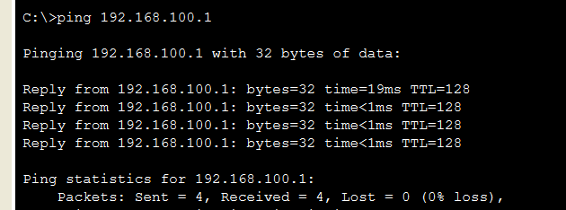

* **Client 1 (Student) -> Client 1 (Faculty)**

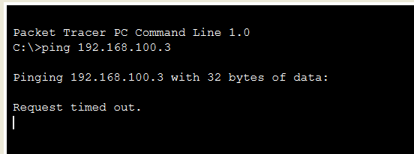

* **Server (Student) > Client 1 (Student)**

* **Anywhere - > Client 2**

